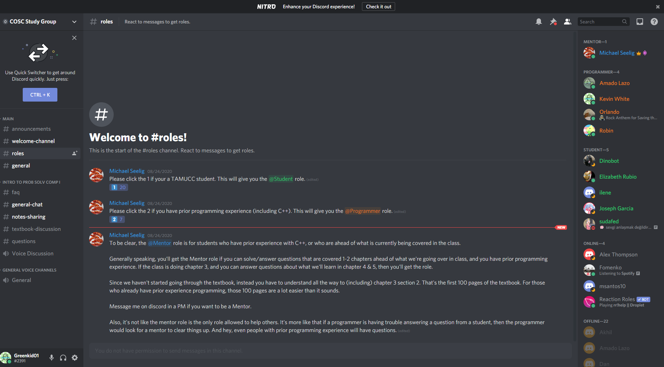­­­One of the first opportunity’s I had to open up with others was when Michael Seelig sent out mass emails about a study group he wanted to start for the computer science group, I joined as it would allow me to easily ask for help as well as help others. He added 3 rolls. Student, Programmer, and Mentor based on your computer science background related to C++. This gave me the opportunity to help others because I’m fluent in both Java and JavaScript. I am hoping to work ahead and be able to put myself into the mentor roll and be able to help everyone. One of the things I want to do when I get older is become a teacher. So why not see if I like it now, as well as be able to practice. I was worried about this year as well so hopefully I can ask some non-computer science related questions as well. I feel a lot more conferrable with this study group available.